**CSCI 333 Assignment 01**

**Variables, Statements, Strings, and Graphics**

1. **(10 points) Write a program that prompts the user to input an integer that represents cents. The program will then calculate the smallest combination of coins that the user has. For example, 27 cents is 1 quarter, 0 nickle, and 2 pennies. That is 27=1*25+0*5+2*1.**

**Write the program**

**input = int(input("Enter number of Cents: "))**

**varQuaters = input//25**

**varDimes = (input-(varQuaters * 25))//10**

**varNickle = (input-((varDimes*10)+(varQuaters*25)))//5**

**varPenny = input - ((varQuaters*25)+ (varDimes*10) + (varNickle*5))**

**print ("")**

**print("The possible smallest combination of coins are:")**

**print("Pennies: {}".format(varPenny))**

**print("Nickles: {}".format(varNickle))**

**print("Dimes: {}".format(varDimes))**

**print("Quarters: {}".format(varQuaters))**

**Screenshot of the output**

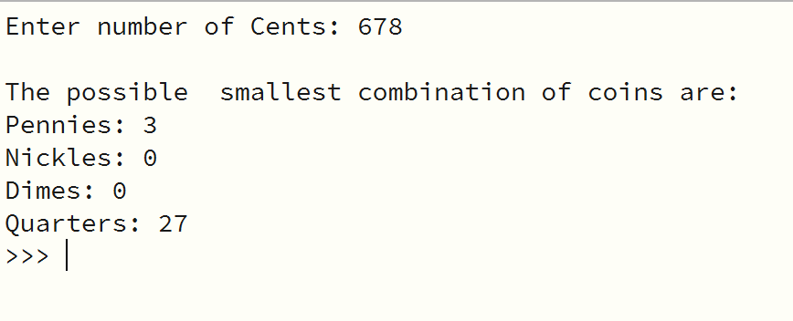

1. **(10 points) Write a program that displays the Olympic rings. Color the rings in the Olympic colors.**

**Write the program**

**from ezgraphics import GraphicsWindow**

**new_width = 500**

**new_height = 500**

**window = GraphicsWindow(new_width, new_height)**

**canvas = window.canvas()**

**canvas.setLineWidth(5)**

**canvas.setOutline("blue")**

**canvas.drawOval(75, 150, 100, 100)**

**canvas.setLineWidth(5)**

**canvas.setOutline("black")**

**canvas.drawOval(179, 150, 100, 100)**

**canvas.setLineWidth(5)**

**canvas.setOutline("red")**

**canvas.drawOval(283, 150, 100, 100)**

**canvas.setLineWidth(5)**

**canvas.setOutline("yellow")**

**canvas.drawOval(120, 200, 100, 100)**

**canvas.setLineWidth(5)**

**canvas.setOutline("green")**

**canvas.drawOval(224, 200, 100, 100)**

**window.wait()**

**Screenshot of the output**

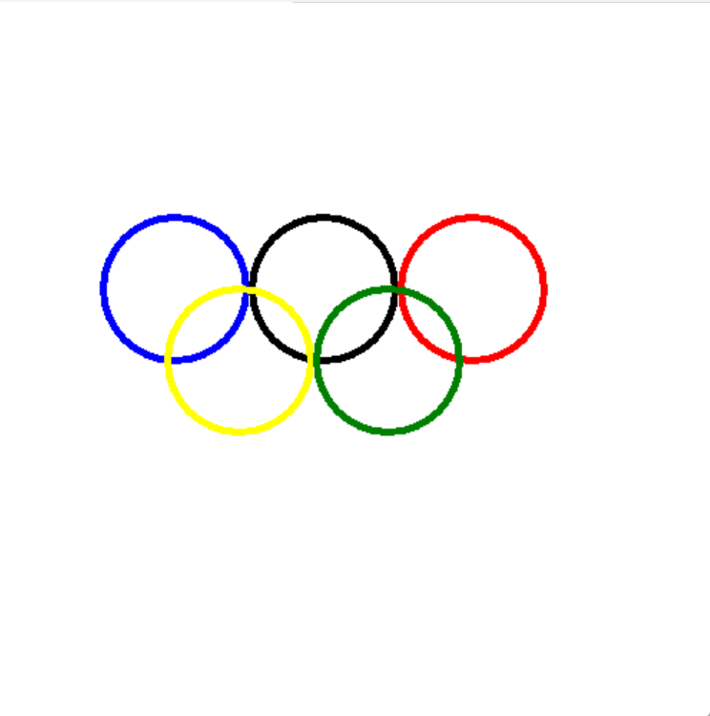

1. **(10 points) Write a program using if/elif/else that computes the income tax according to the schedule below.**

The original U.S. income tax of 1913 was quite simple. The tax was

• 1 percent on the first $50,000.

• 2 percent on the amount over $50,000 up to $75,000.

• 3 percent on the amount over $75,000 up to $100,000.

• 4 percent on the amount over $100,000 up to $250,000.

• 5 percent on the amount over $250,000 up to $500,000.

• 6 percent on the amount over $500,000.

There was no separate schedule for single or married taxpayers.

**Write the program**

**inputAmount=0**

**tax=0**

**inputAmount=int(input("Enter Income:"))**

**if inputAmount<=50000:**

**tax=inputAmount*0.001**

**elif inputAmount>50000 and inputAmount<=75000:**

**tax=inputAmount*0.002**

**elif inputAmount>75000 and inputAmount<=100000:**

**tax=inputAmount*0.003**

**elif inputAmount>100000 and inputAmount<=250000:**

**tax=inputAmount*0.004**

**elif inputAmount>250000 and inputAmount<=500000:**

**tax=inputAmount*0.005**

**else:**

**tax=inputAmount*0.06**

**print ("")**

**print("Income tax:${0}".format(tax))**

**Screenshot of the output**

